**Thruster Report**

|  |  |
| --- | --- |
| **Thruster Ratio:** | **1.200** |
| **Magnetic Field:** | **1000 mT** |
| **Anode Power:** | **1385 W** |
| **Anode Current:** | **6.0 A** |
| **Anode Energy:** | **94519.6 J** |
| **Propellant:** | **Argon 0.500 mg/s** |

**Thruster Details: Nagoya magnet, LaB6 cathode, 1 mm orifice, copper anode, 80 mm internal diameter. CoM correction method: Anode Energy, Pre-offset 0.0 s, Post-offset 100.0 s, Cold-Gas thrust 0.1 mN**

|  |  |  |  |  |  |  |
| --- | --- | --- | --- | --- | --- | --- |
| Thrust | Thrust Eff. | ISP | Total DOF | Coverage Factor | Exp. Uncertainty | Std. Uncertainty |
| 20.7 mN | 31.0 % | 4226.9 sec | 37 | 2.06 | 8.5 mN | 4.1 mN |

**Thrust-Stand Uncertainty Components**

|  |  |  |  |  |  |  |  |
| --- | --- | --- | --- | --- | --- | --- | --- |
|  | Weights | Scale | Hysteresis | Repeatability | Noise | Offset | Drift |
| Value | 0.0 mN | 2.3 mN | 0.7 mN | 0.3 mN | 3.0 mN | 0.9 mN | 1.3 mN |
| DOF | 30 | 6 | 6 | 6 | 31 | 4 | 4 |

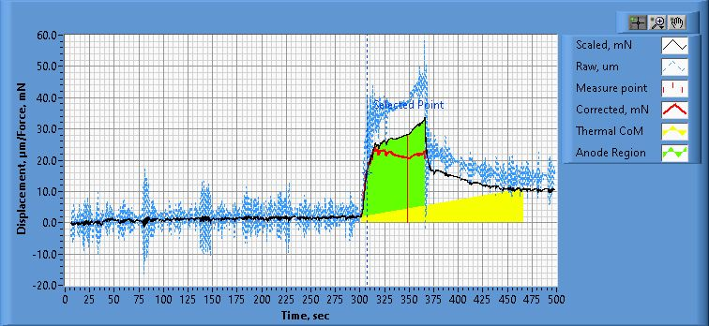

**Figure 1. Thrust Plot**

File Name: Philtech Data 2025.04.15_00.17.17.csv

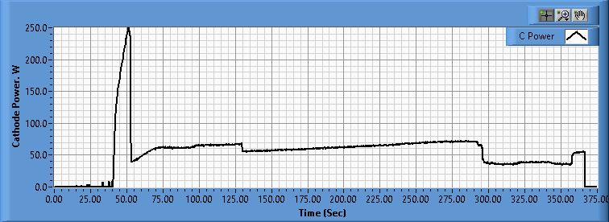

**Figure 2. Cathode Power Plot**

File Name: PSU C Data 2025.04.15_00.17.26.csv

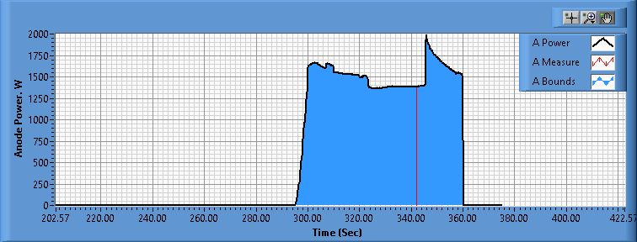

**Figure 3. Anode Power Plot**

File Name: PSU A Data 2025.04.15_00.17.23.csv

**Pre-Cal. Information**

File Name: Philtech Data 2025.04.11_11.23.23.csv

Start/Stop times (24 h): 11:23:29 11:27:14

Sensitivity: 1.65 um/mN

|  |  |  |  |
| --- | --- | --- | --- |
| Offset | Drift | Scale Factor | Scale Std.Dev |
| -1.697 mN | -0.048 mN/s | 0.605 | 2.535 mN |

Plateau values:

|  |  |  |  |  |  |  |  |  |  |  |
| --- | --- | --- | --- | --- | --- | --- | --- | --- | --- | --- |
| Weight 0 | Weight 1 | Weight 2 | Weight 3 | Weight 4 | Weight 5 | Weight 4 | Weight 3 | Weight 2 | Weight 1 | Weight 0 |
| -2.8 mN | 21.1 mN | 37.9 mN | 58.3 mN | 73.8 mN | 101.0 mN | 74.8 mN | 58.6 mN | 38.7 mN | 21.0 mN | -1.0 mN |

**Post-Cal. Information**

File Name: Philtech Data 2025.04.15_00.17.17.csv

Start/Stop times (24 h): 00:26:46 00:28:48

Sensitivity: 1.61 um/mN

|  |  |  |  |
| --- | --- | --- | --- |
| Offset | Drift | Scale Factor | Scale Std.Dev |
| -11.999 mN | -0.076 mN/s | 0.621 | 2.331 mN |

Plateau values:

|  |  |  |  |  |  |  |  |  |  |  |
| --- | --- | --- | --- | --- | --- | --- | --- | --- | --- | --- |
| Weight 0 | Weight 1 | Weight 2 | Weight 3 | Weight 4 | Weight 5 | Weight 4 | Weight 3 | Weight 2 | Weight 1 | Weight 0 |
| -3.0 mN | 19.4 mN | 36.8 mN | 57.1 mN | 73.3 mN | 101.2 mN | 75.5 mN | 58.2 mN | 38.4 mN | 20.7 mN | -2.1 mN |